Curriculum Newsletter: Chagwa Class Term 2 8th January 2024

Dear parents,

I’m really glad to be working with Chagwa class this term. We’ve got lots of exciting things planned, primarily around the theme of Africa until half term, and Inspirational people- African leaders after.

Here are the topics that we will be studying this term: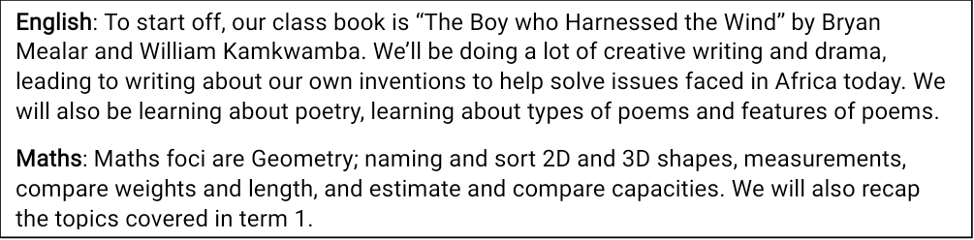

Homework: in line with the school policy, there will be some homework to complete. This will involve daily reading, weekly spellings and occasional other work including Maths, research projects for Topic or a small science investigation. We would really appreciate it if you would take time to help your child, and talk to them about what they have been learning.

Reading: 15 minutes a night; Spelling: 10 minutes a night; Times tables: 5 minutes a night.

Please try to be punctual so that we can start lessons on time. Every moment in class is precious! Drop off is after 7am.

We can’t wait to continue building on the skills we have learnt last year.

Clubs are after school 2.15-3pm

| Year 3: Chagwa Class Mrs M | | | | |  |
| --- | --- | --- | --- | --- | --- |
|  |  |  |  |  |  |
|  | Monday | Tuesday | Wednesday | Thursday | Friday |
| 7:30 | Register | Register | Register | Register | Register |
| 8:00 | Assembly | English | English | ICT | Assembly |
| 8:30 | English | Music |
| 9:00 |  |  |  |  |  |
| 9:30 | Maths | Maths | Dance | English | RE |
| 10:00 |
| 10:30 | PE |
| 11:00 | Chichewa | Maths | Maths | Art |
| 11:30 |
| 12:00 |  |  |  |  |  |
| 12:30 | French | Science | Swimming | Maths |  |
| 1:00 |  |
| 1:30 | DT | Topic | Topic |  |
| 2:00 |  |  |
| Clubs |  |  |  |  |  |

.

All clubs finish at 3pm. Please collect your child from the front of school promptly.

Yours sincerely,

Susan Matiki