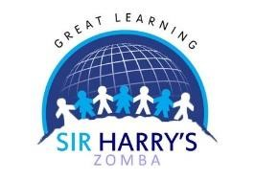
Nursery Class Newsletter
Term 2
Special Schedule
This term we’ll be swimming on Friday please encourage your kids to bring in their swimming costumes, towel, slippers or flip flops. In case it rains we’ll be having show and tell.

We’ll be learning about…
-Rules and routines
-How to wash our hands and keeping safe
-Number recognition 1-10 and counting 1-20
-Counting objects
-New words around the topic (vocabulary)
-Phonic sounds
-Shapes and colours
Our Topic this Term is ‘Africa’
In our topic we’ll be learning about “ Africa” We’ll be looking at what Africa is, African countries ,food,music and dances. To start with we are learning about Malawian food,songs,dances,games just to mention a few. We will also be learning about traditional items and their uses.
On our role play area we’ll be changing every week focusing on our topic. The kids have already started enjoying their learning through play.

Sticker Chart
In Nursery we are continuing an award system for our children. They get stickers for the great work, positive behaviour and a good attitude.

.

